DATA SCIENCE WITH PYTHON
Exploratory Data Analysis and Visualization
Time, age, sex, respiratory overlap, and jurisdiction patterns
━━━━━━━━━━━━━━━━━━━━━━━━━━━━━━━━━━━━━━━━━━━━━━━
WEEK | 2
DATE | 9 August 2026
DATASET | Provisional COVID-19 Deaths by Sex and Age

Student name | Mandal Sahil Naushad
Institution | YuvaIntern
Public-use aggregate mortality data • Reproducible Python workflow

Report map
The document follows the required submission structure. Major sections are separated visually and use Word heading styles for navigation.
- 1. Title Page
- 2. Introduction
- 3. Dataset Overview
- 4. Methodology
- 5. Python Code Sections
- 6. Results and Findings
- 7. Visualizations (described in text)
- 8. Challenges and How They Were Handled
- 9. Discussion
- 10. Conclusion
- 11. References

2. Introduction
This report uses the cleaned Week 1 version of the CDC Provisional COVID-19 Deaths by Sex and Age dataset to answer five specific questions: when national deaths peaked, how the cumulative burden varied by age, whether male and female counts followed the same age pattern, how COVID-19 moved with pneumonia and all-cause mortality, and how the COVID-19 share of total deaths differed across jurisdictions.
The dataset was chosen because the CDC provides the same mortality concepts at monthly, annual, and cumulative grains. That breadth supports useful comparisons, but only after the Week 1 controls for suppression, overlapping age groups, aggregate rows, and partial September 2023 data are carried forward.
Analytical guardrail. Every visualization is built from one declared grain. Counts from All Ages are never added to age subgroups, All Sexes is never summed with Female and Male, and New York City is excluded from state comparisons because it overlaps New York.

3. Dataset Overview
The raw excel sheet has 137,700 rows and 16 columns; the Week 1 clean artifact has 25 columns after parsed types, six suppression flags, a row-level suppression flag, a partial-period flag, and a COVID-19 share field are added. Data are current only through 23 September 2023. The September monthly and 2023 annual rows remain present but are marked partial.
EDA slice | Filter | Rows / units | Reason
National monthly trend | By Month; United States; All Sexes; All Ages | 45 months; 44 complete | One national series without subgroup double counting.
Age profile | By Total; United States; All Sexes; 11 exclusive age bands | 11 | Age bands cover the life course once.
Sex-by-age | By Total; United States; Female/Male; 11 exclusive age bands | 22 | Direct within-age comparison.
Jurisdiction share | By Total; All Sexes; All Ages; exclude US and NYC | 52 | Non-overlapping state/DC/PR profiles.
Correlation | 44 complete national months | 44 | Avoid partial September 2023 and compare aligned series.
Table 1. Analytical slices used in Week 2.
Count fields remain right-skewed, and suppression is concentrated in small cells. The chosen national and cumulative slices are complete for the principal measures. Correlations use Spearman's rank coefficient because the wave-shaped series are non-normal and include extreme pandemic peaks.

4. Methodology
The EDA follows the brief's key steps: choose a suitable public dataset, summarize it, transform only where needed, create multiple visualizations, and interpret each pattern rather than stopping at chart description.

Step 1 — Load the Week 1 clean artifact
I reused the parsed dates, suppression flags, and partial-period marker instead of recoding the source. This protects continuity: the EDA cannot accidentally reinterpret a censored count as zero or include the truncated September 2023 month in peak/low comparisons.

Step 2 — Fix one grain for each question
Each question has a filter contract shown in Table 1. That contract is part of the method, not just code convenience. The data contain multiple valid totals, so a chart can look polished while being numerically wrong if All Sexes or All Ages is combined with components.

Step 3 — Summarize central values and extremes
For national months I calculated death counts and COVID-19 as a percentage of total deaths. For age groups I calculated each band's share of all COVID-19 deaths and COVID-19 as a percentage of all deaths within the band. For jurisdictions I used COVID-19 divided by total deaths; I call it a death-share, not a population risk rate.

Step 4 — Transform and aggregate transparently
Age bands were ordered categorically rather than alphabetically. Male-to-female ratios were calculated within each age band. State shares were ranked only after the United States and New York City were removed. September 2023 stayed on the timeline for visual context but was shaded and excluded from complete-month minima and correlations.

Step 5 — Build annotated visualizations
I used a line chart for time, a count-plus-share dual-axis chart for age, grouped bars for sex, horizontal bars for jurisdiction ranking, and a heatmap for correlations. Titles, units, labels, legends, and partial-period annotations are included so the chart is understandable outside the surrounding text.

Step 6 — Interpret, cross-check, and avoid causal claims
The visual interpretation is cross-checked against exact grouped values. I describe associations and distributional differences, not causes. This matters because the aggregate file has no population denominators, vaccination, infection prevalence, or individual risk factors.

5. Python Code Sections

Code 1 — Imports and continuity load
```python
from pathlib import Path
import matplotlib.pyplot as plt
import numpy as np
import pandas as pd
import seaborn as sns
DATA_PATH = Path("Provisional COVID-19 Deaths by Sex and Age.csv")
df = pd.read_csv(
"cleaned_covid_deaths.csv",
parse_dates=["data_as_of", "start_date", "end_date"],
low_memory=False,
)
EXCLUSIVE_AGE_GROUPS = [
"Under 1 year", "1-4 years", "5-14 years", "15-24 years",
"25-34 years", "35-44 years", "45-54 years", "55-64 years",
"65-74 years", "75-84 years", "85 years and over",
]
```
Code explanation and output interpretation
- The code reads the Week 1 output, retaining its real snake_case field names and parsed date columns.
- The explicit age list is mutually exclusive; alternative overlapping bands such as 0–17, 18–29, and 30–39 are deliberately omitted from age sums.
- The resulting table still contains all 137,700 rows, while each analysis below selects a coherent subset.

Code 2 — Build the complete national monthly series
```python
national_monthly = df.query(
"group == 'By Month' and state == 'United States' "
"and sex == 'All Sexes' and age_group == 'All Ages'"
).sort_values("start_date")
complete_months = national_monthly.loc[~national_monthly["is_partial_period"]].copy()
complete_months["covid_pct_total"] = (
100 * complete_months["covid_deaths"] / complete_months["total_deaths"]
)
peak = complete_months.loc[complete_months["covid_deaths"].idxmax()]
print(peak[["start_date", "covid_deaths", "covid_pct_total"]])
```
Code explanation and output interpretation
- The filters produce one row per national month and prevent age/sex aggregate duplication.
- The partial-period flag excludes September 2023 from peak and correlation calculations while allowing it to be shown as incomplete context.
- January 2021 is the maximum complete month with 105,565 COVID-19 deaths, equal to 28.25% of all reported deaths that month.

Code 3 — Calculate the cumulative age profile
```python
age = df.query(
"group == 'By Total' and state == 'United States' and sex == 'All Sexes'"
).loc[lambda x: x["age_group"].isin(EXCLUSIVE_AGE_GROUPS)].copy()
age["age_group"] = pd.Categorical(
age["age_group"], categories=EXCLUSIVE_AGE_GROUPS, ordered=True
)
age = age.sort_values("age_group")
age["share_of_covid_pct"] = 100 * age["covid_deaths"] / age["covid_deaths"].sum()
age["covid_pct_total"] = 100 * age["covid_deaths"] / age["total_deaths"]
print(age[["age_group", "covid_deaths", "share_of_covid_pct", "covid_pct_total"]])
```
Code explanation and output interpretation
- Categorical ordering places age groups in life-course order instead of lexical order.
- The 11 selected bands sum to the All Ages COVID-19 total, providing a direct aggregation check.
- The three 65+ bands account for 868,831 deaths, or 75.76% of the cumulative total.

Code 4 — Compare male and female counts within age
```python
sex_age = df.query(
"group == 'By Total' and state == 'United States' "
"and sex in ['Female', 'Male']"
).loc[lambda x: x["age_group"].isin(EXCLUSIVE_AGE_GROUPS)]
sex_age = sex_age.pivot(index="age_group", columns="sex", values="covid_deaths")
sex_age = sex_age.reindex(EXCLUSIVE_AGE_GROUPS)
sex_age["male_to_female"] = sex_age["Male"] / sex_age["Female"]
print(sex_age.sort_values("male_to_female", ascending=False).head())
```
Code explanation and output interpretation
- Pivoting aligns Female and Male counts for the same age band, so each ratio has a meaningful numerator and denominator.
- Across the selected bands, male deaths total 629,728 versus 517,046 female deaths, a ratio of 1.218.
- The largest age-specific ratio is 1.75 in ages 45–54, indicating the biggest proportional sex gap occurs before the oldest ages.

Code 5 — Rank jurisdictions by COVID-19 share of all deaths
```python
jurisdiction = df.query(
"group == 'By Total' and sex == 'All Sexes' and age_group == 'All Ages'"
).loc[lambda x: ~x["state"].isin(["United States", "New York City"])].copy()
jurisdiction["covid_pct_total"] = (
100 * jurisdiction["covid_deaths"] / jurisdiction["total_deaths"]
)
ranked = jurisdiction.sort_values("covid_pct_total", ascending=False)
print(ranked[["state", "covid_pct_total"]].head(15))
```
Code explanation and output interpretation
- This metric standardizes COVID-19 counts by all recorded deaths within each jurisdiction, reducing but not eliminating scale differences.
- New Jersey is highest at 11.40%, Vermont is lowest at 4.10%, and the 52-jurisdiction median is 8.95%.
- The result is a composition measure, not an age-standardized or population-based mortality rate, so it should not be labeled risk.

Code 6 — Measure rank correlations and draw the heatmap
```python
measure_cols = [
"covid_deaths", "total_deaths", "pneumonia_deaths",
"pneumonia_covid_deaths", "influenza_deaths", "pic_deaths"
]
corr = complete_months[measure_cols].corr(method="spearman")
sns.heatmap(corr, annot=True, fmt=".2f", cmap="vlag", center=0,
vmin=-1, vmax=1, square=True)
plt.title("Correlation among national monthly death-count series")
plt.tight_layout()
plt.show()
```
Code explanation and output interpretation
- Spearman correlation measures whether series rise and fall in a similar rank order without assuming a linear Gaussian relationship.
- COVID-19 and pneumonia deaths have a strong positive coefficient of 0.919; COVID-19 and total deaths are also strongly associated at 0.845.
- The coefficients describe synchronized monthly movement, not proof that one series causes the other.

6. Results and Findings
Finding | Exact result | Interpretation
Cumulative national COVID-19 deaths | 1,146,774 | 9.32% of 12,303,399 total deaths in the file's cumulative period.
Peak complete month | January 2021: 105,565 | COVID-19 represented 28.25% of all deaths that month.
August 2023 | 3,844 | 96.36% below the January 2021 peak; September is partial and not used for the comparison.
Age 65+ cumulative share | 868,831; 75.76% | Three-quarters of deaths are concentrated in ages 65 and older.
Largest age count | 85+: 311,863 | The oldest band has the highest count.
Highest within-band COVID share | 65–74: 10.24% | The largest count and largest within-band share are not the same concept.
Male/female total ratio | 1.218 | Male cumulative deaths exceed female deaths across the exclusive age scheme.
Largest sex ratio | 45–54: 1.75 | The proportional male gap peaks in midlife.
Jurisdiction range | New Jersey 11.40%; Vermont 4.10% | Death composition differs by 7.30 percentage points.
COVID/pneumonia monthly Spearman | 0.919 | The two respiratory mortality series move closely together over time.
Table 2. Main EDA findings from reproducible filtered slices.
The time series is wave-shaped rather than a smooth decline. A single average would hide the January 2021 peak and later rebounds. The age results also separate two ideas: the 85+ group has the most COVID-19 deaths, but ages 65–74 have the highest COVID-19 share of that group's all-cause deaths. The grouped sex chart shows male excess across most adult ages, with the strongest proportional separation at 45–54.
Jurisdiction differences are material, but they should be treated as descriptive. The 11.40% New Jersey figure means COVID-19 was a larger component of all recorded deaths in this period than in Vermont; it does not adjust for age structure or population. The correlation heatmap indicates shared wave timing among COVID-19, pneumonia, and all-cause deaths and helps motivate lagged respiratory features in later forecasting.

7. Visualizations (described in text)
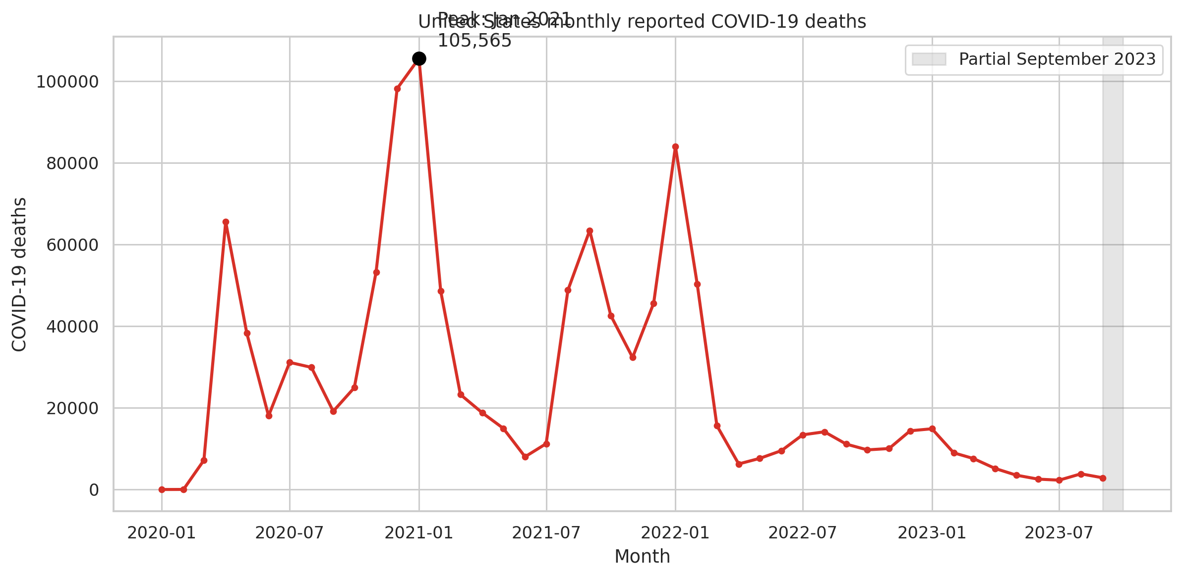
Figure 1. United States monthly COVID-19 deaths. September 2023 is shaded because it ends on 23 September.
Technical reading: a monthly line chart places Start Date on the x-axis and reported COVID-19 deaths on the y-axis; the highest complete point is annotated. Analytical reading: burden arrives in distinct waves, and January 2021 dominates the series. The shaded final month prevents a truncated reporting period from being mistaken for a confirmed decline.
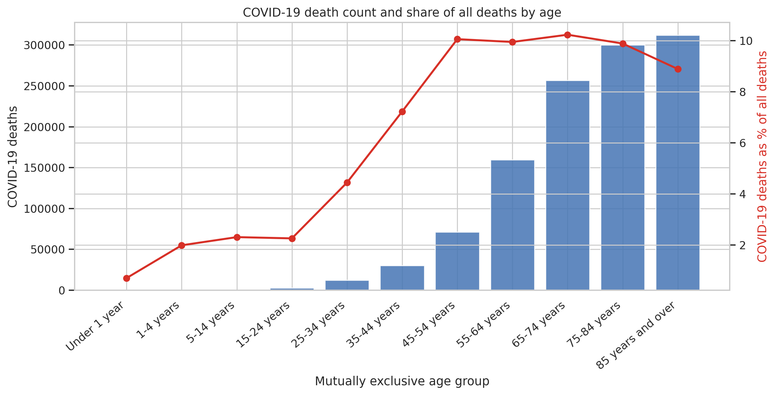
Figure 2. Cumulative COVID-19 count (bars) and COVID-19 percentage of all deaths (line) by mutually exclusive age group.
Technical reading: bars use the left count axis, while the red line uses the right percentage axis. Analytical reading: counts rise sharply with age, but the share of all deaths peaks at 65–74 and then declines slightly in older bands because all-cause mortality also rises steeply. The two axes make that difference visible.
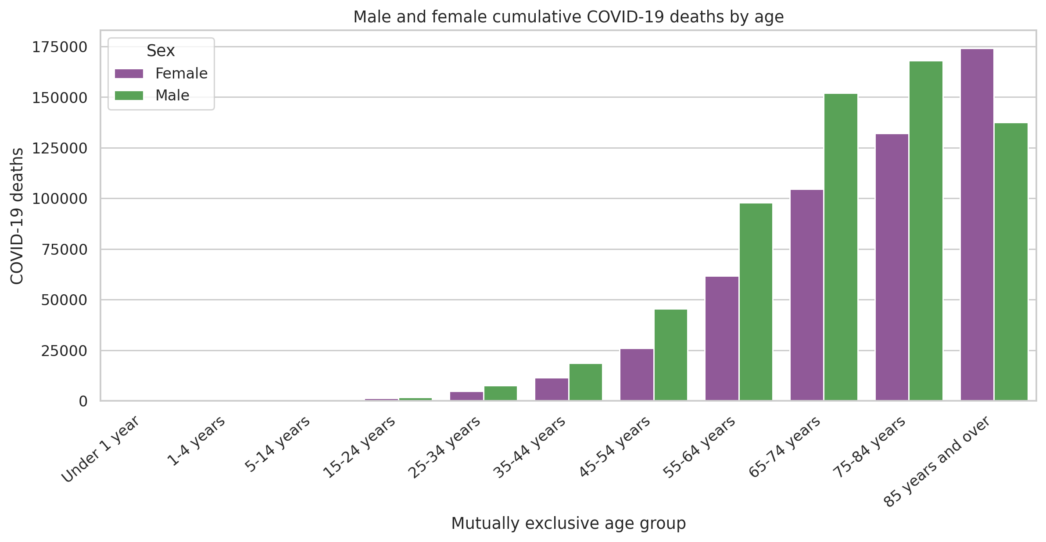
Figure 3. Male and female cumulative COVID-19 deaths within the same exclusive age groups.
Technical reading: paired bars compare sex within each ordered age band and use a shared death-count scale. Analytical reading: male deaths are generally higher, and the proportional gap is most pronounced at 45–54. Absolute female counts approach male counts at the oldest ages, which is consistent with the changing composition of the surviving population but cannot be causally resolved here.
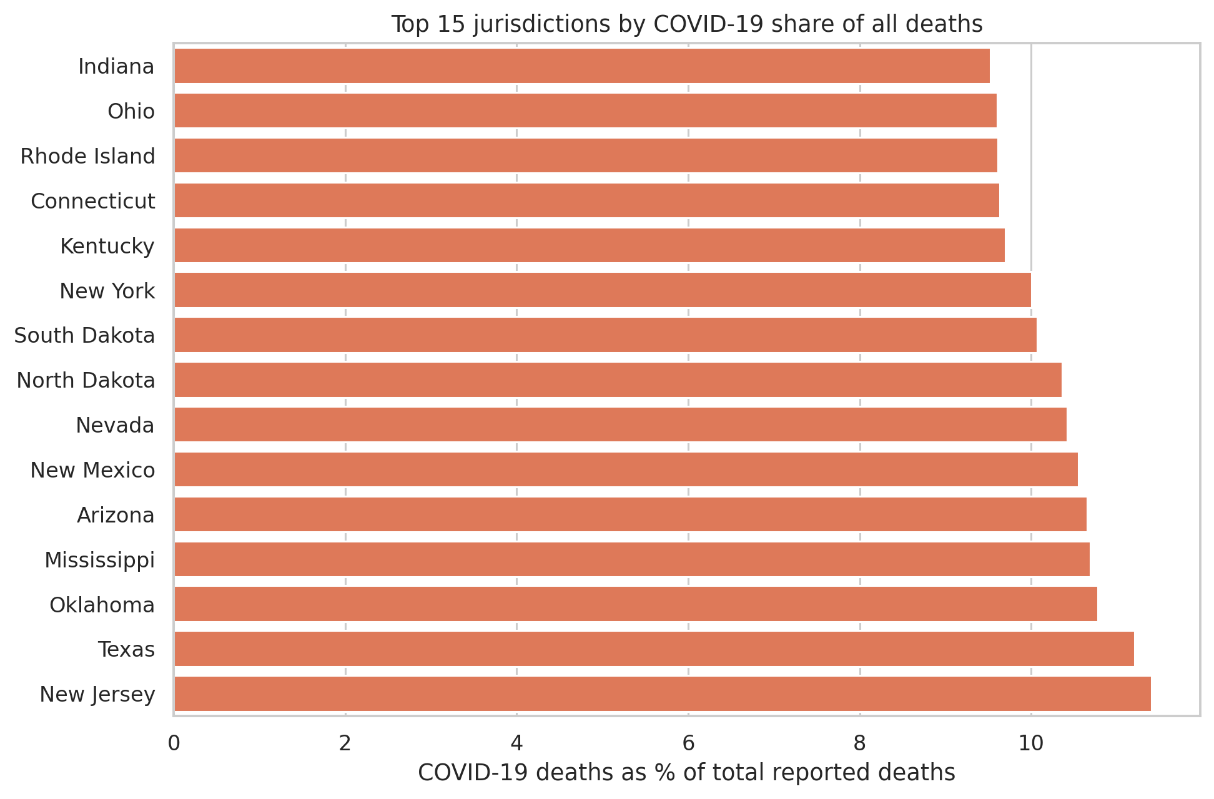
Figure 4. Fifteen highest jurisdictions by cumulative COVID-19 deaths as a percentage of total deaths.
Technical reading: a sorted horizontal bar chart shows the percentage on the x-axis and jurisdiction on the y-axis. Analytical reading: the top group is not simply the largest states, which shows why normalizing by total deaths changes the ranking. The chart still lacks age and population standardization, so it is a screening view rather than a performance league table.
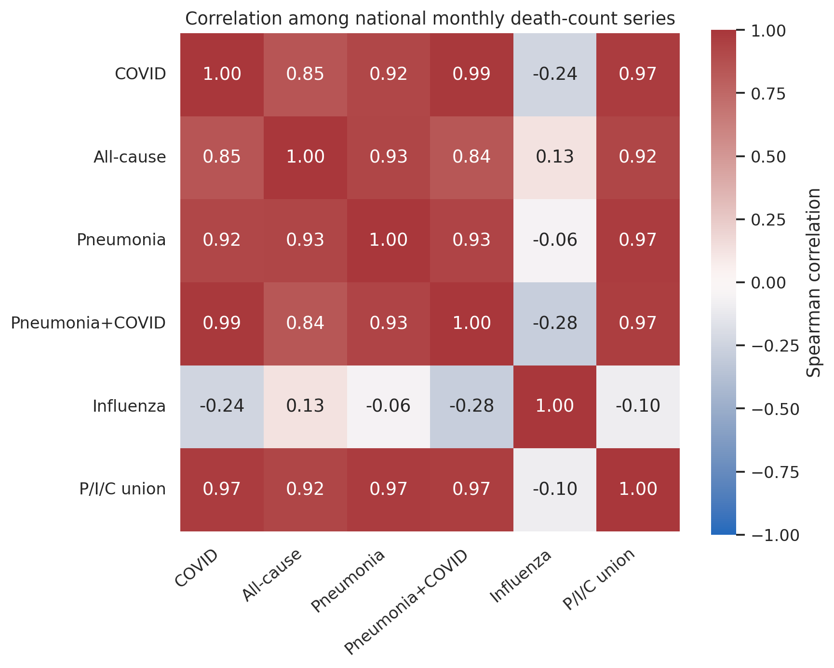
Figure 5. Spearman rank-correlation heatmap for six national monthly mortality series over complete months.
Technical reading: cells range from −1 to +1 and display coefficients. Analytical reading: COVID-19, pneumonia, pneumonia-plus-COVID, and the P/I/C union form a tightly moving respiratory block. Influenza is less synchronized, reflecting a different seasonal and pandemic-era pattern.

8. Challenges and How They Were Handled
- Overlapping age bands made a naïve age sum invalid. I selected the 11-band mutually exclusive scheme and verified that it reconciles to All Ages.
- September 2023 ends on the 23rd. I shaded it in the trend but excluded it from peak, minimum, and correlation calculations.
- New York City overlaps the New York state geography. It was removed from cross-jurisdiction ranking while New York remained.
- Suppression is non-random in small cells. National and cumulative slices minimize the issue; where suppression remains, values are not silently converted to zero.
- Large count ranges could visually flatten small age groups. A companion percentage line and explicit table provide context instead of hiding the count scale.
- A high correlation could be misread as causation. The narrative uses association language and identifies shared timing and overlapping respiratory definitions.

9. Discussion
Practically, the results point to an age-concentrated but not age-exclusive burden. The 65+ population accounts for 75.76% of deaths, so long-term-care readiness and older-adult protection remain central when studying the historical period. At the same time, the 1.75 male-to-female ratio at 45–54 identifies a subgroup whose proportional gap would disappear if analysis focused only on the oldest-age counts.
The monthly wave pattern means a model should be evaluated in chronological blocks. A random train/test split would distribute the same pandemic wave across both sets and overstate generalization. The strong COVID-pneumonia association suggests lagged pneumonia may carry predictive information, but overlapping definitions and concurrent coding mean it must not be interpreted as an independent causal driver.
Limitations are substantial. The data are aggregate, provisional, and frozen in September 2023. They record occurrence rather than individual exposure, contain interval-censored small counts, and provide no denominators for population risk or age standardization. Visual differences cannot identify policy effects, infection rates, or biological mechanisms.
If EDA were skipped, later clustering could be driven by raw population size, a model could train on incomplete September, and overlapping age rows could create impossible targets. The transformations used here—grain filters, exclusive age categories, complete-period flags, and scale-aware shares—directly define the safe feature set for Weeks 3 and 4.

10. Conclusion
The EDA found 1,146,774 cumulative U.S. COVID-19 deaths, a January 2021 monthly peak of 105,565, a 75.76% share among ages 65+, a cumulative male/female ratio of 1.218, and wide jurisdiction variation in COVID-19's share of all deaths. COVID-19 and pneumonia monthly deaths have a Spearman correlation of 0.919, reinforcing the respiratory-wave pattern.
The next stage will cluster 52 non-overlapping jurisdictions using standardized, scale-free mortality profiles. The cluster features will use age share, sex share, respiratory overlap, and wave timing rather than raw death counts so population size does not decide the groups by itself.

11. References
- Centers for Disease Control and Prevention, National Center for Health Statistics. Provisional COVID-19 Deaths by Sex and Age. Dataset page: https://data.cdc.gov/National-Center-for-Health-Statistics/Provisional-COVID-19-Deaths-by-Sex-and-Age/9bhg-hcku
- CDC data download used for source verification: https://data.cdc.gov/api/views/9bhg-hcku/rows.csv?accessType=DOWNLOAD
- CDC WONDER provisional mortality access noted by the publisher as the successor source: https://wonder.cdc.gov/mcd-icd10-provisional.html
- McKinney, W. pandas: Python Data Analysis Library. https://pandas.pydata.org/
- Harris, C. R. et al. (2020). Array programming with NumPy. Nature, 585, 357–362. https://numpy.org/
- Waskom, M. L. (2021). seaborn: statistical data visualization. Journal of Open Source Software, 6(60), 3021. https://seaborn.pydata.org/
- Pedregosa, F. et al. (2011). Scikit-learn: Machine Learning in Python. Journal of Machine Learning Research, 12, 2825–2830. https://scikit-learn.org/
- Hunter, J. D. (2007). Matplotlib: A 2D Graphics Environment. Computing in Science & Engineering, 9(3), 90–95. https://matplotlib.org/

